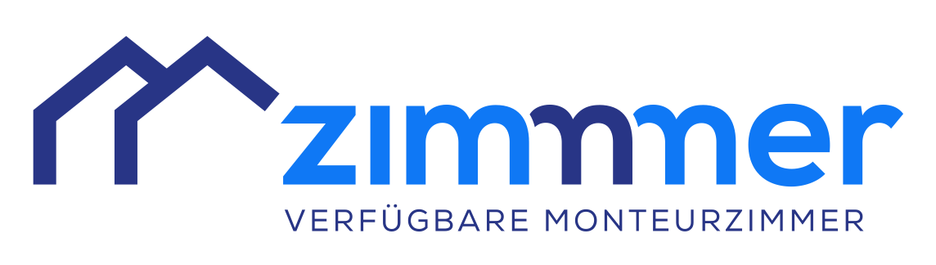

**Our House Rules**

# General:

If you find anything missing in our accommodation, in need of improvement or if we can assist you in any way, please contact us. We will be happy to help. If there any damage occurs to the equipment, please let us know. In most cases, matters of this kind can be resolved quickly and easily through your employer.

# Kitchen/Refrigerator/Microwave:

Dishes, cutlery, pots and pans have to be rinsed after use. Please leave the kitchen as you would like to find it on your next visit. Refrigerators and microwaves in the rooms are to be kept clean. The shared kitchen is equipped with pots, pans and cooking utensils.

**Dishes/Cutlery:**

Dishes, cutlery and glasses are to be brought by the guests and cleaned by themselves. It is stored in each guest’s room.

**Sheets:**

All beds are equipped with sheets. The laundry may not be washed, damaged or taken. Sheets are changed regularly. If you want to use your own sheets, please let us know. Damaged or stolen sheets will be charged.

**Room/Bathroom:**

The entire room including the bathroom/WC is cleaned weekly. A towel and a shower mat are provided by us. They are changed regularly. This laundry may not be washed or taken. Damaged or stolen towels will be charged.

# Smoking:

Smoking is not allowed in our accommodation! Please only smoke in designated areas outside.

# Valuables/Burglary/Theft:

There is no liability for valuables and wardrobe.

# Parking:

Please use the parking spaces in front of the building. No parking on public streets or on neighboring properties.

**We wish you a pleasant stay!**

Name Ansprechperson +43 1234 567890 **E-Mail:** email@unterkunft.at

**Adresse:**  Schöne Unterkunft, Zimmerweg 1, 1234 Heimat